UNLOCKING SALES INSIGHTS FOR REVENUE GROWTH














Project Domain

Excel

A Project Report

submitted in partial
fulfilment

of the requirements of the AICW Project

b
y
:

Institution
:

Marwadi University

Year
-

2026

Student Name

Bora Usha

Student Email

b
orausha32@gmail.com

Guide

Ms. Uma Maheswari

AICW Fellowship Project Report | 2026

ACKNOWLEDGEMENT

I would like to express our sincere gratitude to our project guide for their valuable guidance and support throughout this project. I was also thankful to the Edunet Foundation, Microsoft, LinkedIn, and SAP for providing the AICW Fellowship opportunity and learning resources. Finally, i would like to thank our friends and family for their encouragement during the completion of this project.

ABSTRACT OF THE PROJECT

This project focuses on cleaning and analyzing a retail sales dataset and creating visual dashboards to generate meaningful business insights. The dataset contained sales transaction records including product category, region, quantity, price, discount, and profit.
The raw dataset was cleaned by checking for duplicate records, correcting data formats, and validating numerical values. Microsoft Excel were used to analyze the dataset and build visual dashboards such as sales trends, profit by product category, and regional sales performance.
The final output of this project includes a cleaned dataset and interactive visualizations that help understand business performance. This project demonstrates how data analytics tools can transform raw sales data into useful insights for decision-making.

TABLE OF CONTENTS

Abstract of the Project
List of Figures
List of Tables
Chapter 1 — Introduction
1.1 Problem Statement
1.2 Motivation
1.3 Objectives
1.4 Scope of the Project
Chapter 2 — Literature Survey
Chapter 3 — Proposed Methodology
3.1 System Design
3.2 Modules / Components Used
3.3 Data Flow Diagram (DFD)
3.4 Advantages
3.5 Requirement Specification
Chapter 4 — Implementation and Results
4.1 Data Cleaning Results
4.2 Visualization / Output Results
Chapter 5 — Discussion and Conclusion
References
Appendices

LIST OF FIGURES

Figure No. | Figure Title / Description | Page No.
Figure 1 | Raw / uncleaned dataset screenshot | 12
Figure 2 | Cleaned dataset or validation summary screenshot | 13
Figure 3 | Main dashboard / report / output screenshot | 14
Figure 4 | Additional chart or visualization screenshot | 15

LIST OF TABLES

Table No. | Table Title / Description | Page No.
Table 1 | Hardware Requirements | 10
Table 2 | Software Requirements | 11

CHAPTER 1

Introduction

This chapter introduces the project undertaken as part of the AICW Fellowship Program. It outlines the background, the problem being addressed, the motivation behind this work, and the objectives and scope of the project i.e. Unlocking sales insights for revenue growth

1.1 Problem Statement
A retail organization might receive sales information from various operational systems like
- Inconsistent date format
- Incorrect or manually computed totals
- Region and category inconsistencies
- Limited visibility into sales trends and performance
Due to such issues, management is having a hard time keeping an accurate record of sales revenue, determining high and low-performing products, and assessing the sales regions’ performance.
"The objective of the project is to clean and standardize the sales data, as well as create dashboards to ensure the accuracy of the sales insights."

1.2 Motivation
The motivation behind this project is to understand how raw business data can be transformed into useful information through data cleaning and visualization. Data analytics is an important skill in modern industries, and tools like Excel are widely used for business intelligence.

1.3 Objectives
- Understand the structure of the retail sales dataset.
- Clean the dataset by removing duplicates and fixing errors.
- Handle missing values and inconsistent data formats.
- Analyse sales data using Excel.
- Create visual dashboards to show insights.

1.4 Scope of the Project
This project focuses on cleaning and analysing retail sales data using Microsoft Excel. The project includes data preprocessing, analysis, and dashboard creation. Advanced machine learning models or real-time data systems are outside the scope of this project.

CHAPTER 2

Literature Survey

2.1 Existing Work and Research
Many organizations use data analytics tools to understand business performance. Tools like Excel are commonly used to clean datasets and create dashboards.
Research in business intelligence shows that visualization tools help organizations identify patterns such as sales trends, customer behaviour, and product demand.

2.2 Tools and Technologies Review
Microsoft Excel Used for:
- Data cleaning
- Removing duplicates
- Using formulas
- Pivot tables

2.3 Gaps Identified
- Many datasets contain errors and inconsistencies.
- Manual data cleaning takes time.
- Visual dashboards are needed for better decision-making.
- This project addresses these issues by combining data cleaning and visualization techniques.

CHAPTER 3

Proposed Methodology

3.1 System Design
The project follows these steps:
- Import dataset into Excel
- Clean the dataset
- Perform analysis
- Create visual dashboards
- Generate insights Flow:
Raw Data → Data Cleaning → Data Analysis → Visualization → Insights

3.2 Modules / Components Used
Module 1 – Data Ingestion Import dataset into Excel.
Module 2 – Data Cleaning
- Remove duplicates
- Fix date formats
- Check missing values Module 3 – Data Analysis
- Use pivot tables
- Calculate totals and averages
Module 4 – Visualization
Create charts and dashboards.

3.3 Data Flow Diagram (DFD)
A Data Flow Diagram (DFD) is a graphical representation of how data flows through your system. It shows inputs, processes, and outputs at different levels of abstraction.
DFD Level 0:
Raw Sales Data → Data Cleaning System → Dashboard Output

DFD Level 1:
Raw Data
↓
Data Validation
↓
Data Cleaning
↓
Data Analysis
↓
Visualization

3.4 Advantages
- Improves data accuracy
- Helps identify business trends
- Saves time in analysis
- Provides easy-to-understand visual insights

3.5 Requirement Specification

Hardware Requirements
Component | Specification
Processor | Intel Core i3 or higher (i5/i7 recommended)
RAM | Minimum 4 GB (8 GB recommended)
Storage | Minimum 50 GB free disk space
Display | 1366 x 768 resolution or higher
Table 1

Software Requirements
Software | Details
Operating System | Windows 10 / 11 or macOS
Microsoft Excel | Microsoft 365
Table 2

CHAPTER 4

Implementation and Results

This chapter presents the actual implementation of the project and the results obtained at each stage. Screenshots of dashboards, cleaned datasets, or generated content should be inserted where indicated.

4.1 Data Cleaning Results
Describe the data cleaning process and present the before/after comparison of your dataset.
- Dataset source: Dataset is downloaded from Kaggle
- Original dataset size: Number of rows-1001; columns in the raw data-10
- Issues found: duplicates, null values, wrong data types, formatting inconsistencies,
- Cleaning steps applied: Removing the duplicates from data, checking the wrong data types.
- Cleaned dataset size: number of rows after cleaning- 1001; number of columns after cleaning- 15
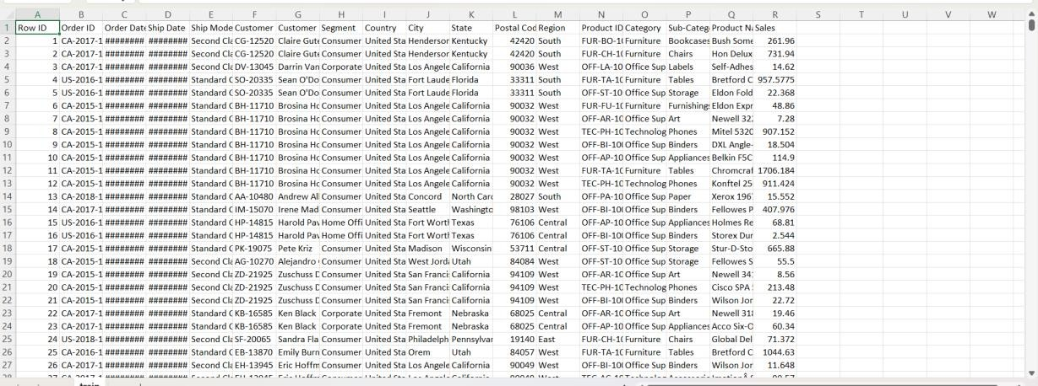
Figure 1.1(uncleaned data)
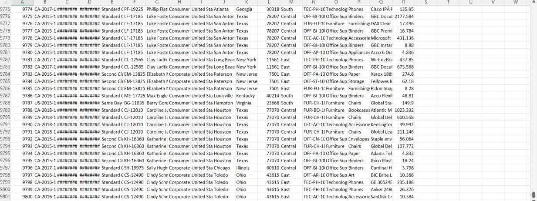
Fig 1.2(uncleaned data)

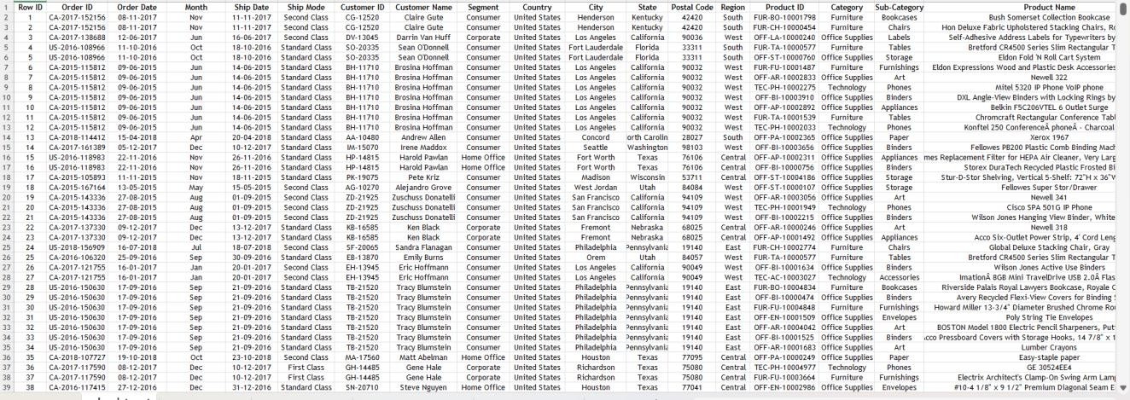
Fig 2.1(Cleaned Data)
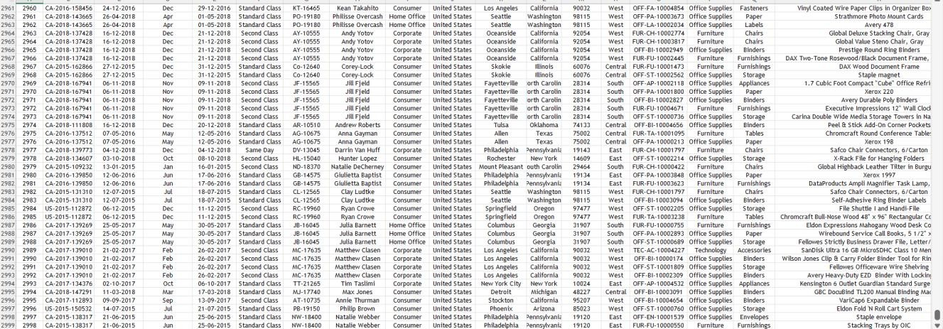
Fig 2.2(Cleaned data)

4.2 Visualization / Output Results
Chart 1 – Monthly Sales Trend
Line chart showing sales over time.
Chart 2 – Sales by Subcategory
Bar chart comparing sales in different subcategories.
Chart 3 – Sales by Category
Column chart showing sales in different category.
Chart 4 – Sales by region
Pie chart showing sales in a region.
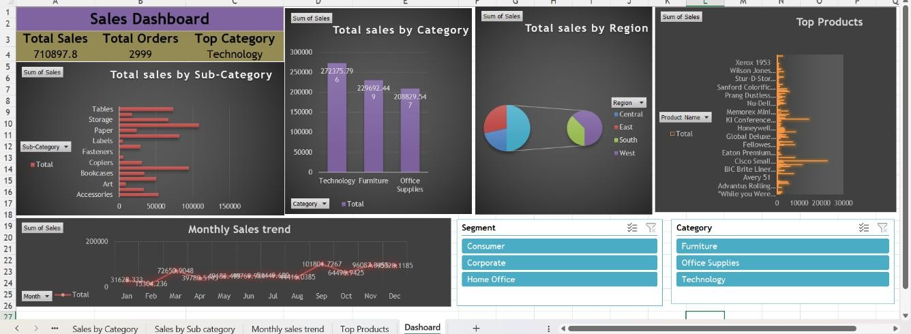
Fig -3 (Dashboard)
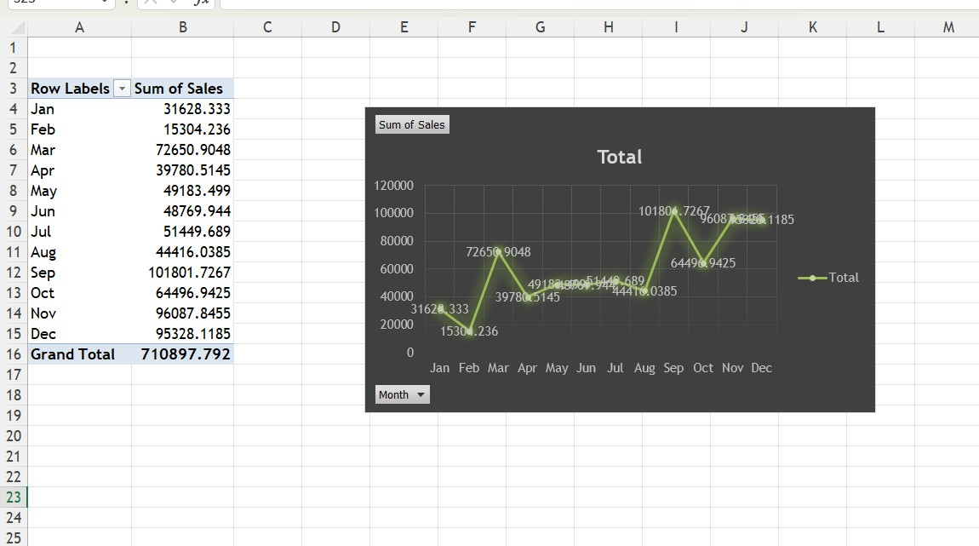
Fig- 4.1(Line Chart)
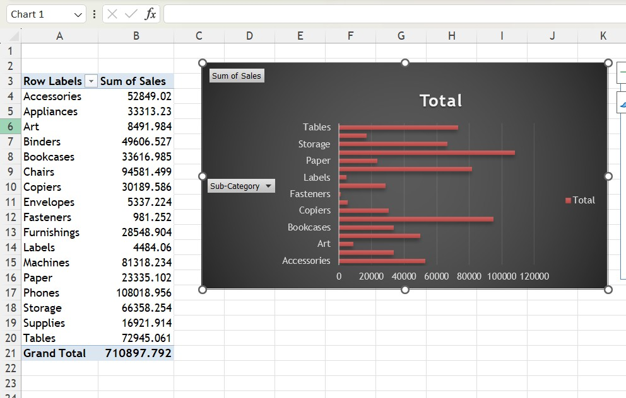
Fig 4.2 (Bar Chart)
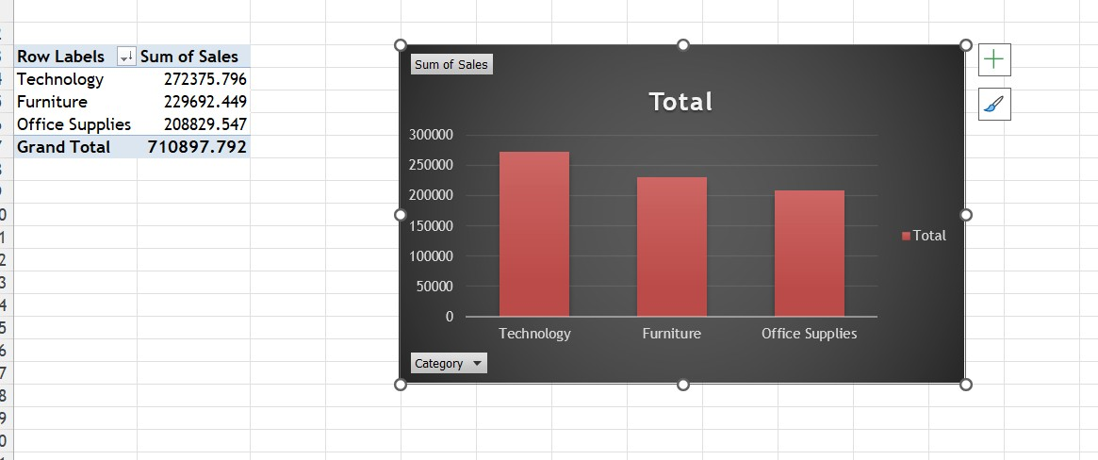
Fig 4.3(Column Chart)
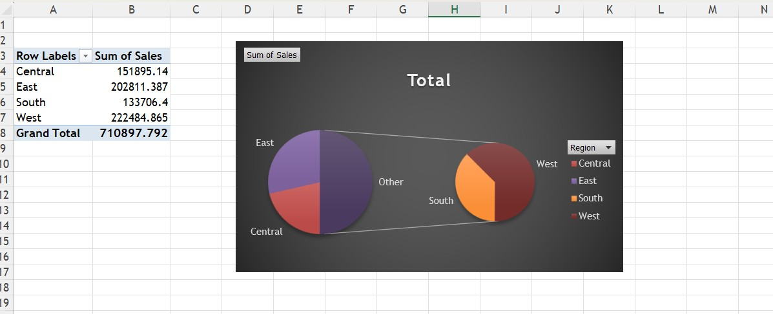
Fig 4.4 (Pie Chart)

CHAPTER 5

Discussion and Conclusion

5.1 Key Findings
- Some regions generate higher sales than others.
- Certain product categories produce higher profits.
- Customer payment preferences vary.
5.2 Project Links
Kaggle: https://www.kaggle.com/datasets/rohitsahoo/sales-forecasting

5.3 Limitations
- Dataset is limited to sample data.
- No real-time updates.
- Advanced machine learning models were not used.

5.4 Future Work
Possible improvements:
- Apply machine learning for sales forecasting.
- Integrate real-time business data.
- Build web-based dashboards.

5.5 Conclusion
This project demonstrated how retail sales data can be cleaned and analyzed using Excel. By creating visual dashboards, the project helps identify business patterns such as sales trends and product performance.

REFERENCES

List all references, research papers, tutorials, and documentation used in the project in the format below:
Microsoft Corporation. Microsoft Excel Documentation. Available at:
https://support.microsoft.com/en-us/excel
Edunet Foundation. AICW Fellowship Program Guidelines. 2026.

APPENDICES

Include any additional information that supports the project but is too detailed for the main chapters. This may include:

Appendix A — Sample Dataset

Fig 6
The dataset used in this project contains retail sales transactions including transaction ID, date, customer information, product category, sales amount, and profit. The screenshot above shows a sample of the dataset used for analysis.

Appendix B — Key Excel Formulas Used
The following Excel tools and features were used during the project:
- Pivot Tables – Used to summarize sales data by region, product category, and time.
- Sorting and Filtering – Used to organize and examine specific parts of the dataset.
- Remove Duplicates – Used to clean the dataset and eliminate duplicate records.
- Line Chart – Used to visualize monthly sales trends.
- Bar Chart – Used to compare sales across different regions.
- Pie Chart – Used to show the distribution of payment methods.
These tools helped transform raw data into meaningful insights.

